**Green Vs. Brown Energy**

Electric plants produce electricity from two major resources,one is Green energy resources which refers to environment friendly resources like solar power and wind.the other type is brown energy resource which refers to environment unfriendly resources like coal and fossil fuel.

Green energy is more expensive than brown energy due to rare energy resources and more complicated equipment which is needed during energy production.Therefore, it can increase the electricity price and reduce costumer tendency to use electric vehicles.

For example China mainly rely on coal for electricity production,it cause a sever environment pollution which can neutral the effect of electric vehicle in reducing air pollution.

Therefore,while governments encourage consumers to purchase electric vehicle market,also should invest more in the field of green energy to make sure there is a good infrastructure for green electricity supply.

**Global Oil Price**

Global oil price has direct effect on electric vehicle market . Cheaper oil price can reduce the demand for electric vehicles, in result can bring down the adoption rate of electric vehicles, as well as higher oil price can boost electric vehicle market and motivate consumer to purchase electric vehicles.

There are lots of argue about recent oil price fall and its effect on Electric vehicle market growth, but the point is how long will cheap oil continue?

According to the Commodity Forecast released by The World Bank in January 2015, that world crude oil price will see an smooth increase from $53.2/barrel in 2015 to around $103.4/barrel in 2025.

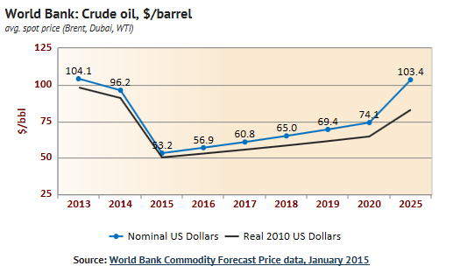

as can be seen , short term oil price fall from $104/barrel in 2013 to $53.2/barrel in 2015 maybe has slowed down the electric market growth but from a long term view oil price increase will motivate more and more consumer to buy electric vehicle and save money on fuel price.

**Oil supply availability**

Crude oil is lifeblood in modern world, Politicians always concern about sustainable access to crude oil to secure their energy supply network system. But the key question is: can we have unlimited access to crude oil forever?

Tow third of oil remaining reserves are in the Middle East.

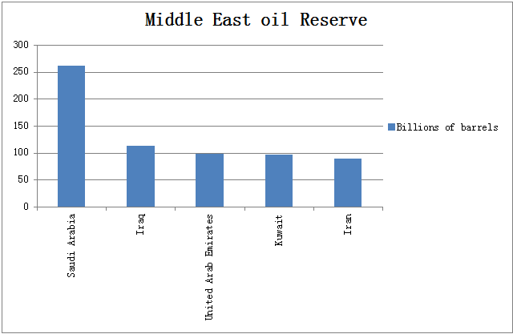

As can be seen, There are an estimated 1.3 trillion barrels of proven oil reserve left in the world’s major fields, which at present rates of consumption will be sufficient to last 40 years.

By 2040, production levels may be down to 15 million barrels per day – around 20% of what we currently consume. It is likely by then that the world’s population will be twice as large, and more of it industrialized.

Therefore, Electric vehicle seems to be a good substitute for internal combustion engine cars to decrease the dependence of transportation system on crude oil.

**Electricity price**

electricity price is one of the main factor that has direct effect on the development of electric vehicle market and electric vehicle charging market.

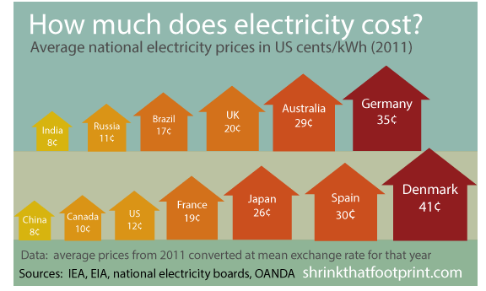

As different countries produce electricity from different resources and also provide different subside , so the electricity price is very variable all around the world.

Governments needs to provide more subsidies on electricity price in order to encourage more consumer to purchase and use electric vehicles.